TRANSFERRING A BLOCK OF DATA BETWEEN MEMORY LOCATIONS AIM:
To write an assembly language program to transfer a block of data from source to destination in 8085 Microprocessor

APPARATUS REQUIRED:
- 8085 microprocessor kit 1
- Power card 1
- Keyboard 1

ALGORITHM:
- Initialize BC pair with 4200H
- Initialize DE pair with 4300H
- Initialize H Reg with number of bytes to be transferred
- Load a Byte from source address and Store the same on Destination address
- Check all the data bytes transferred if no repeat step 4
- Stop the program

Output:
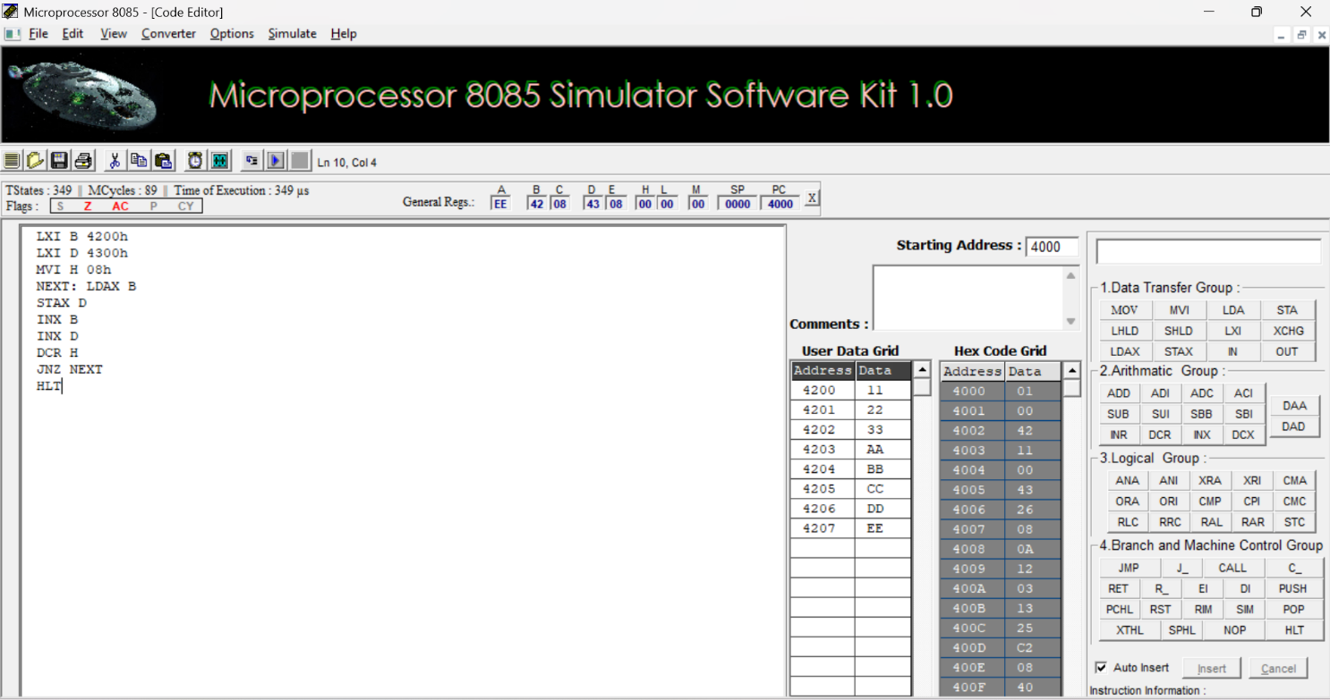
Result:
Thus, an assembly language program for Transferring of given 8-bit numbers was written, executed and Verified the Result successfully using 8085 kit.

